14.83: The pressure difference, neglecting the thickness of the wing, is 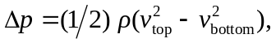 and solving for the speed on the top of the wing gives

The pressure difference is comparable to that due to an altitude change of about 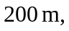 so ignoring the thickness of the wing is valid.

